Coil Yield
- Traceability is needed because of the welding wire
- Times for each piece of equipment for standards
  - FL1
  - FL2
  - FL3
- Weights on and off operations for calculating yields
Change the headers: “Outgoing Gauge” to “Outgoing Gauge/Diameter”.
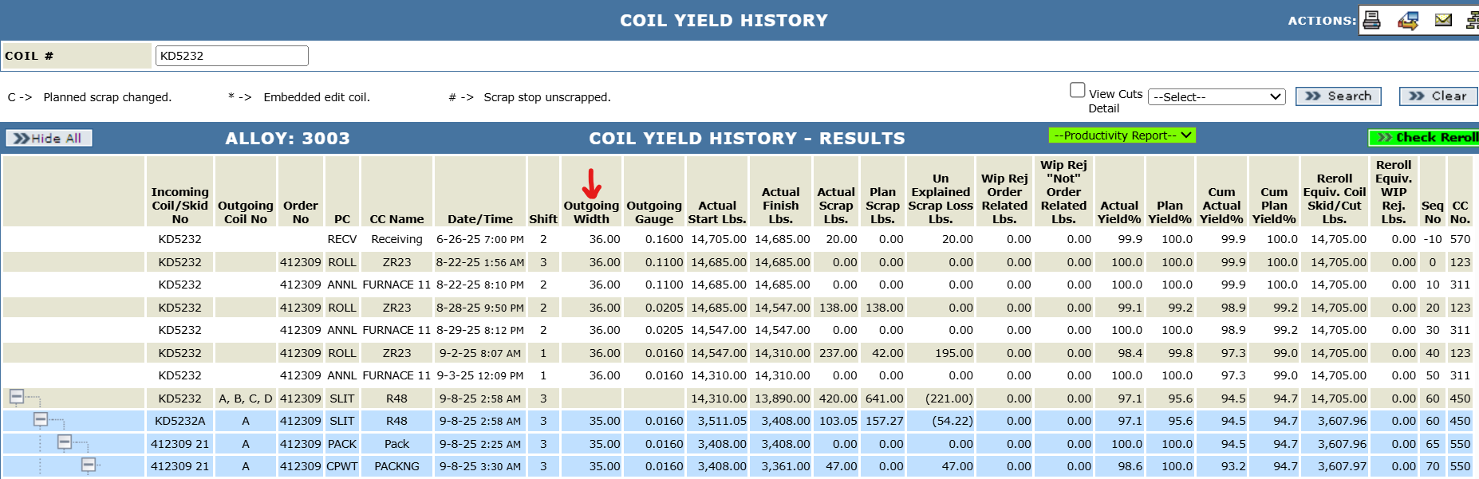
Add a new checkbox “Flat Wire”. Change the field “Coil #” to “Coil/Bundle#”, “Gauge” to “Gauge/Diameter”.
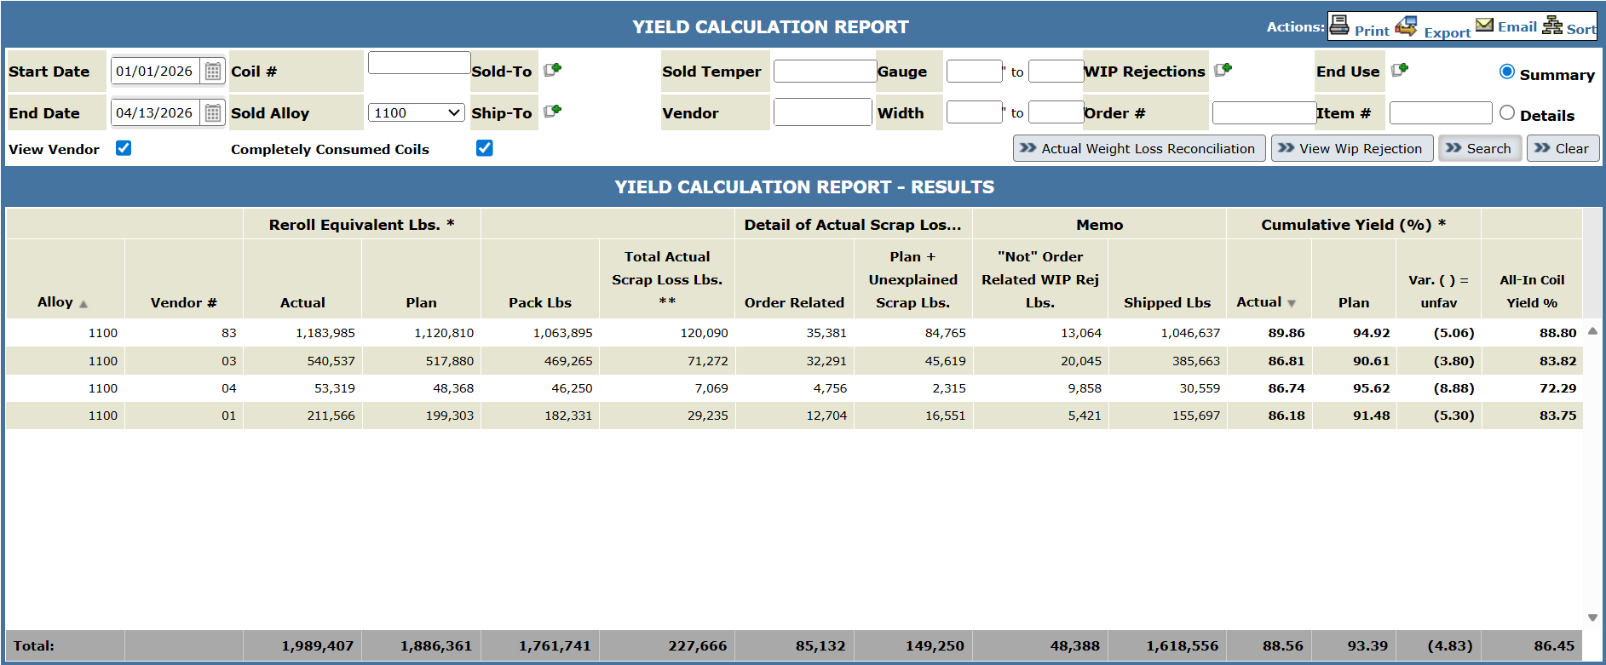

Cost Ledger
- Ability to report the wire separate like B2B
- Will the industry code; example 510 “Flat Fin” Chart, or 530 Spiral Fin Hudson, remain the same regardless of pancake, tolled, or flat-wire routings?
- Need to apply costing standards for the aluminum wire

